**Have at least two short dialogues that show when your agent is not able to handle the conversation properly (screenshot 2 instances):**

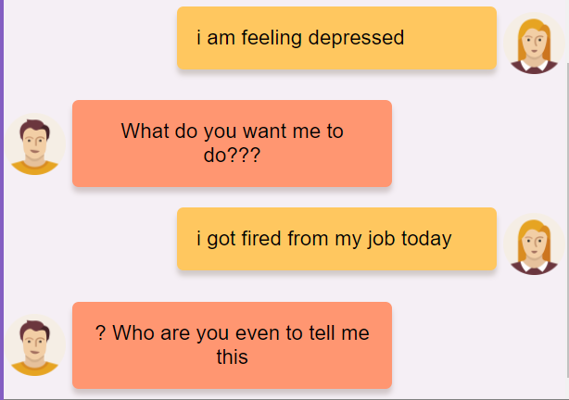

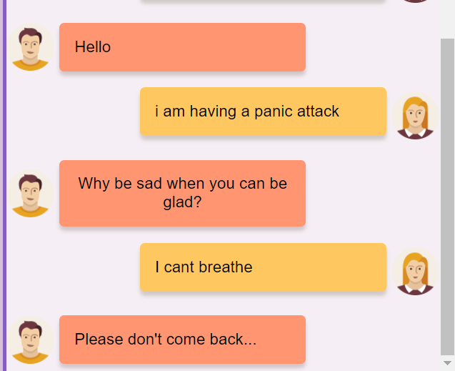

**Record any hours the group spent in meetings :**

**Meeting HOURS:**

G & D - Feb 10th - 0.5 hours

Feb 10th - 3 hours

Feb 15th - 3 hours

Feb 17th - 3 hours

Feb 24 - 3 hours

March 1 - 2 hours

March 2 - 2 hours

G & D - Mar 4th - 1 hour